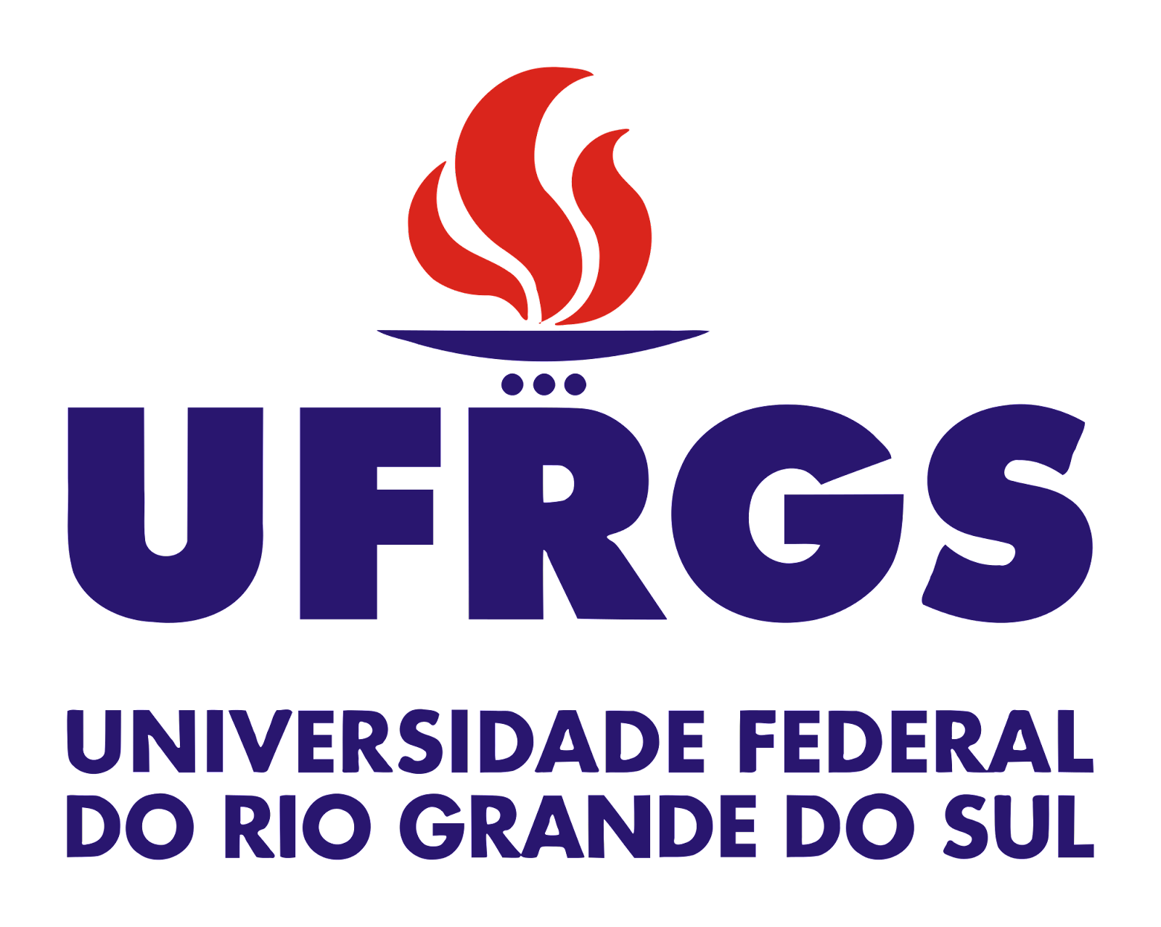**UNIVERSIDADE FEDERAL DO RIO GRANDE DO SUL PROJETO DE EXTENSÃO - TURMA 6**

**Professoras: Camila, Érica e Maria Cláudia Grupo/país: Netherlands**

**Nomes: Alessandra, Ilza Daniele, Iuri, Karla Renata**

**Getting to know the the country**

Fill in the table below with the information you gather on the internet about the country your group chose.

|  |  |  |
| --- | --- | --- |
| **Geography** | Map of the country | Link:https://www.google.com/maps/d/edit?mid=1hmDEB4ooSWo1yLV_W1D-mtBMIjDNE-U&ll=52.2728602597765%2C4.37811264839052&z=10 |
| Main cities | Amsterdam, Rotterdam, Lisse, Haia |
| Most popular kinds of transportation | Bikes and boats |
| Climate | unstable and hazy |

|  |  |  |
| --- | --- | --- |
| **History** | Historical events | https://www.discoverwalks.com/blog/amsterdam/10-most-famous-historical-events-that-happened-in-the-netherlands/ |
| Important figures(people) | Anne Frank |
| Ethnic groups | Nordic European |

|  |  |  |
| --- | --- | --- |
| **Culture** | Language(s) | Dutch, English, German |
| Food/ drinks | Stroopwafel, Kroket |
| Leisure activities | Ride a Bike, walk in around the city, take a boat tour |
| Politeness |  |
| Impoliteness | Don’t go with the kids to the red light district |

|  |  |  |
| --- | --- | --- |
| **Tourism** | Kinds of visa for Brazilians | UE visa – tourism for 90 days |
| Tours |  |
| Landscapes/ Museums/ Monuments |  |
| Souvenirs/ typical goods |  |

|  |  |  |
| --- | --- | --- |
| **Money** | Average cost of a two-way plane ticket | R$ 5500,00 – 6000,00 |
| Average cost of a hotel daily rate | R$ |
| Average cost of individual meals per day | R$ |